**Date:22.08.25**

**TASK 4**

**Mini-Max Algorithm**

Implementation of Mini-Max algorithm uses recursion to search through the game-tree using python by applying following constraints.

•In this algorithm two players play the checker’s game; one is called MAX and other is called MIN.

•Both the players fight it as the opponent player gets the minimum benefit while they get the maximum benefit.

•Both Players of the game are opponent of each other, where MAX will select the maximized value and MIN will select the minimized value.

•The minimax algorithm performs a depth-first search algorithm for the exploration of the complete game tree.

•The minimax algorithm proceeds all the way down to the terminal node of the tree, then backtrack the tree as the recursion.

**Tools : Python**

**PROBLEM STATEMENT: CO2 S3**

Developing a simple AI for a two-player game where each player takes turns choosing a move. The game can be represented as a binary tree, where leaf nodes represent the final outcome scores of the game. The MAX player aims to maximize the score, while the MIN player tries to minimize it. Write a Python program using the Minimax algorithm to determine the optimal value the MAX player can guarantee, assuming both players play optimally. Use a game tree with a depth of 3 and 8 possible outcome values at the leaves.

**Date:22.08.25**

**TASK:4**

**Implementation of Mini-Max algorithm using recursion to search through the Game - tree**

**AIM**

To implement the Minimax algorithm using Python for a two-player turn-based game in order to determine the optimal move for the maximizing player.

**ALGORITHM**

1.Start at the Root Node of the game tree (representing the current state of the game).

2.Define Depth of the tree (how many moves ahead to look) and whose turn it is:

* MAX tries to maximize the score.
* MIN tries to minimize the score.

3. If current node is a terminal (leaf) node or depth limit is reached:

* Return the score (evaluation of that state).

4. If it's MAX's turn:

* Initialize best to -∞.
* For each child node:
  + Recursively call minimax() for the child node (next depth, MIN's turn).
  + Update best = max(best, value returned).
* Return best.

5. If it's MIN's turn:

* Initialize best to +∞.
* For each child node:
  + Recursively call minimax() for the child node (next depth, MAX's turn).
  + Update best = min(best, value returned).
* Return best.

6. Continue recursively until the root node receives the optimal value, representing the best move the MAX player can make.

**PROGRAM**

**Minimax Tree Game AI**

def minimax(depth, node_index, is_max_player, scores, max_depth):

# Base case: if we've reached the leaf node

if depth == max_depth:

return scores[node_index]

if is_max_player:

# MAX player's turn: choose the maximum value

left = minimax(depth + 1, node_index * 2, False, scores, max_depth)

right = minimax(depth + 1, node_index * 2 + 1, False, scores, max_depth)

return max(left, right)

else:

# MIN player's turn: choose the minimum value

left = minimax(depth + 1, node_index * 2, True, scores, max_depth)

right = minimax(depth + 1, node_index * 2 + 1, True, scores, max_depth)

return min(left, right)

# Example: Terminal scores of leaf nodes

scores = [3, 5, 6, 9, 1, 2, 0, -1] # 8 leaf nodes (2^3)

# Tree depth (3 levels: root -> depth 0 to leaf -> depth 3)

max_depth = 3

# Start minimax from root (depth 0, index 0, MAX player's turn)

optimal_value = minimax(0, 0, True, scores, max_depth)

# Output the result

print("The optimal value is:", optimal_value)

**OUTPUT**

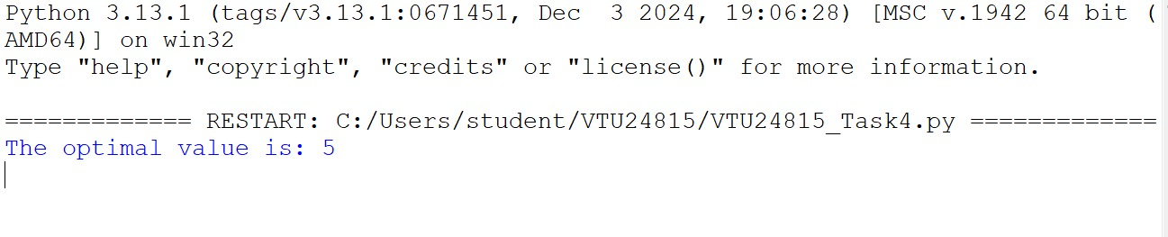

**RESULT**

Thus, the Minimax algorithm using Python for a two-player turn-based game in order to determine the optimal move for the maximizing player was successfully executed and output was verified.